## Skill-React

# React Hands-on Lab: Ticketbookingapp

# Code:

## Terminal Instructions:

**# 1. Create the React app**

**npx create-react-app ticketbookingapp**

**# 2. Navigate into the project folder**

**cd ticketbookingapp**

**# 3. Start the React development server**

**npm start**

## Code(App.js):

## 

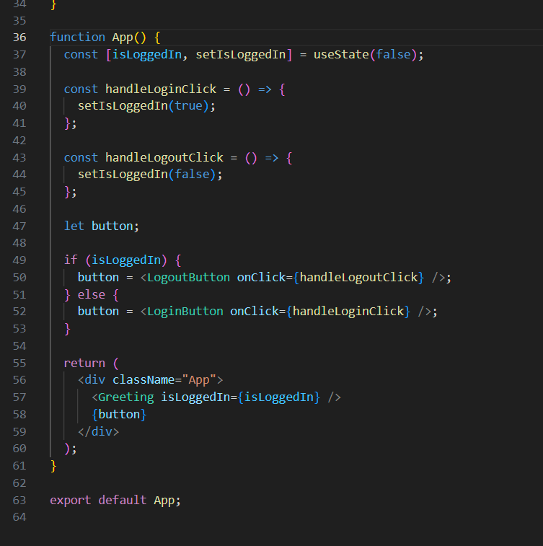

# Output:

